SID Methodology Lab

1. Sort

Contents

Lab Overview 2

Learning Objectives 2

Lab Resources 2

Lab Tasks 2

1. Sort 6

Label entities 6

# Lab Overview

Learn how to transform your relational data model into a NoSQL architecture that the Adobe Experience Platform’s Real-Time Customer Profile can leverage. Follow the SID methodology steps of sort, identify, and de-normalization.

# Learning Objectives

**What should you walk away with after taking this Lab?**

* Be able to sort entities into their appropriate XDM class for the Real-Time Customer Profile’s primary entity and supporting entities:
  + Primary Entity – Individual Profile (traits) and Experience Event (behaviors)
  + Supporting Entities - lookup schemas

# Lab Tasks

1. Sort
   1. Entities into Individual Profile (traits)
   2. Entities into Experience Event (behaviors)
   3. Entities into lookup tables

**DEMO: Reference Demo Data model  - Answer Key**

**LAB: Connection 5G Data Warehouse ERD:**

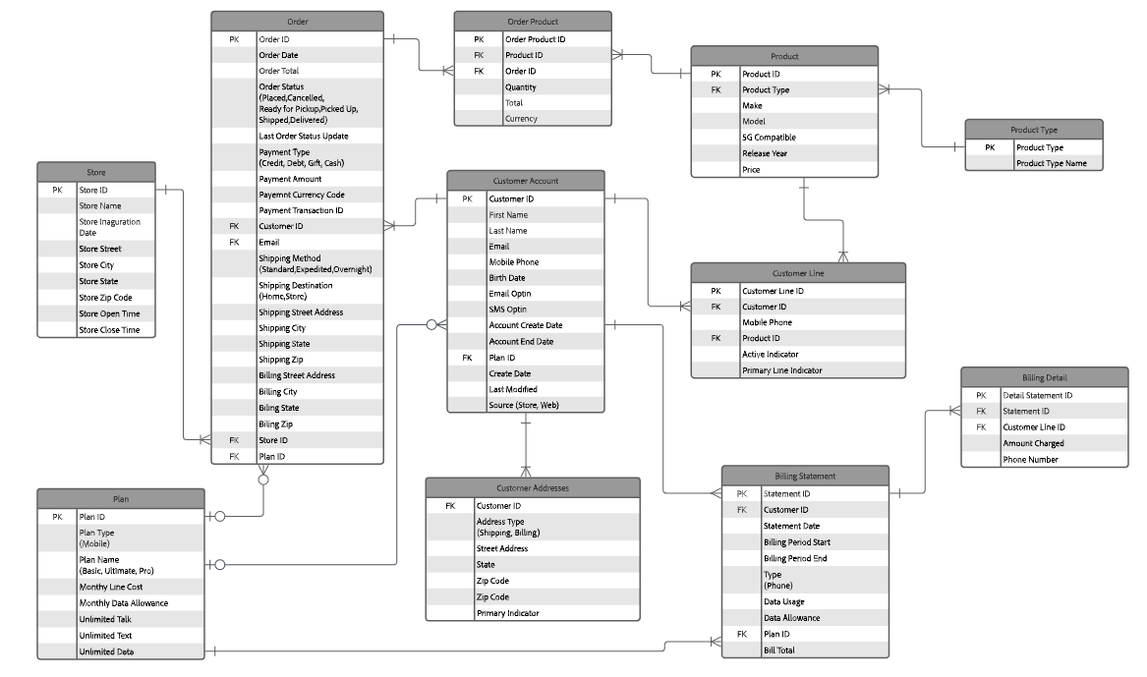

**LAB: Customer Streaming Payload ERD:**

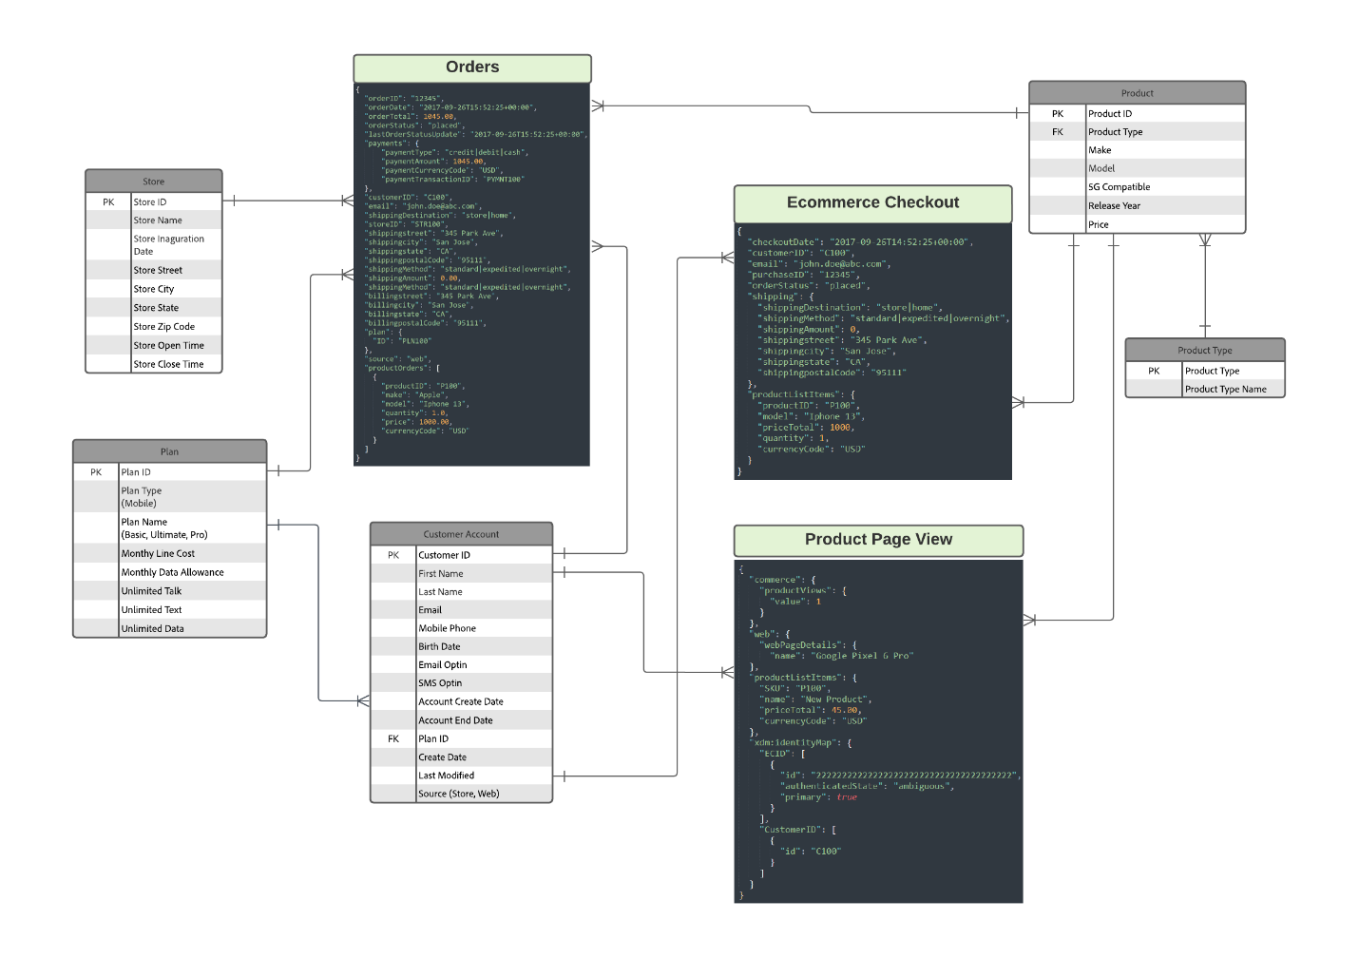

# 1. Sort

## Label entities

Label the entities from the customer data warehouse ERD and the customer streaming payload ERD with the appropriate XDM Class label for Individual Profile, Experience Event, and Lookup

1. Identify all the source entities which represent a person or an individual in both the customer data warehouse ERD and the customer streaming ERD. Mark those with a **"P" signifying it is part of the XDM Individual Profile class.   
     
   *Note:*** *Only mark the entities which uniquely represent the person.*
2. Identify all the source entities which represent the behavior of a person or an individual in both the customer data warehouse ERD and the customer streaming ERD. Mark those as **"E" signifying it is part of the XDM Experience Event class.  
     
   *Note:*** *Only mark the entities which uniquely represent a person’s behavior.*
3. Identify all the source entities which represent lookup data and directly related to either the "**P"** or **"E"** entities you have marked in both the customer data warehouse ERD and the customer streaming ERD. Mark those as **"L"** signifying it is part of a customer defined XDM class.  
     
   *Note: Lookup tables can only be 1 join level away from either a “P” or “E” labeled schema*

|  |  |
| --- | --- |
| Hint | * **Individual Profile (traits) –** uniquely describes the traits of a person (i.e. name, email, address, preferences, etc.) * **Experience Event (behaviors) –** describe interactions and touchpoints a person has with a brand/company (i.e. web page visit, purchase, call to call center, application submit, etc.) * **Lookup –** provide additional information about the Individual Profile or Experience Event |